20 August 2026
ASX ANNOUNCEMENT
First Drill Results Demonstrate Scale and Grade at Jaws: 41.15m at 4.66g/t Gold
Includes 7.62m at 18.67g/t Au, with individual 1.52m samples grading up to 41.0g/t Au
Nunavut, Canada – Manhattan Gold Corporation Limited (ASX: MHC) ('Manhattan’ or 'the Company') reports exceptional first assay results from its maiden reverse circulation (RC) drilling program at the Jaws gold target within the Hook Lake Project. Drillhole JWS26006b intersected a wide, high-grade gold zone commencing at only 83.82m downhole, materially upgrading the known scale and grade demonstrated by historic drilling.

Key Highlights

- First assays reveal high-grade gold at Jaws: The first four drillholes of the program confirm a broad gold system, with JWS26006b delivering standout wide, high-grade intercepts:
  - JWS26006b returned an exceptional result from the main shear zone at Jaws:
    - 7.62m @ 18.67g/t Au from 85.34m in JWS26006b, within the main shear zone that returned 41.15m @ 4.66g/t Au from 83.82m
    - Exceptional high-grade individual samples of 1.52m @ 33.40g/t Au from 86.87m and 1.52m @ 41.0g/t Au from 89.92m
    - The drillhole ended with 1.52m @ 0.31g/t Au from 199.64m – a new zone of gold mineralisation to be followed up on below historic drilling
  - JWS26002 returned 9.15m @ 1.99g/t Au from 153.92m, confirming down-dip continuation of a historic footwall vein
  - JWS26003 returned 9.15m @ 1.73g/t Au from 35.05m, confirming additional near-surface gold mineralisation including up to 1.52m @ 4.13g/t Au
  - JWS26001 confirmed broad gold mineralisation, with 79.25m @ 0.78g/t Au from 38.10m including 33.53m @ 1.04g/t Au
- Material upside compared to historic drilling: JWS26006b returned higher grades within a thicker mineralised zone than the historic drillhole at this section along the extensive shear zone, highlighting the exceptional discovery potential that remains in the shallow environment
  - Historic hole 133-88-20 returned 22m @ 2.41g/t Au from 100m
- High-grade shoots confirmed within a broad zone: The results support the existence of high-grade shoots within a broader mineralised envelope. Follow-up drilling to focus on shoot geometry and continuity
- Refined geological model at Jaws: Drilling has materially improved the Jaws geological model, indicating the main shear zone lies slightly northwest of historic plans, providing a stronger basis to target interpreted higher-grade cores and plunging shoots
- Aggressive Exploration Pipeline: The 2026 RC program has surpassed 3,000m with 13 drillholes completed, further assays are pending, the rig is now drilling at the high-grade Spectre copper-zinc volcanogenic massive sulphide (VMS) target
- Regional exploration supporting ongoing drill program: Till sampling commencing shortly to evaluate along strike extensions and high-priority targets within the Omega banded iron formation (BIF)
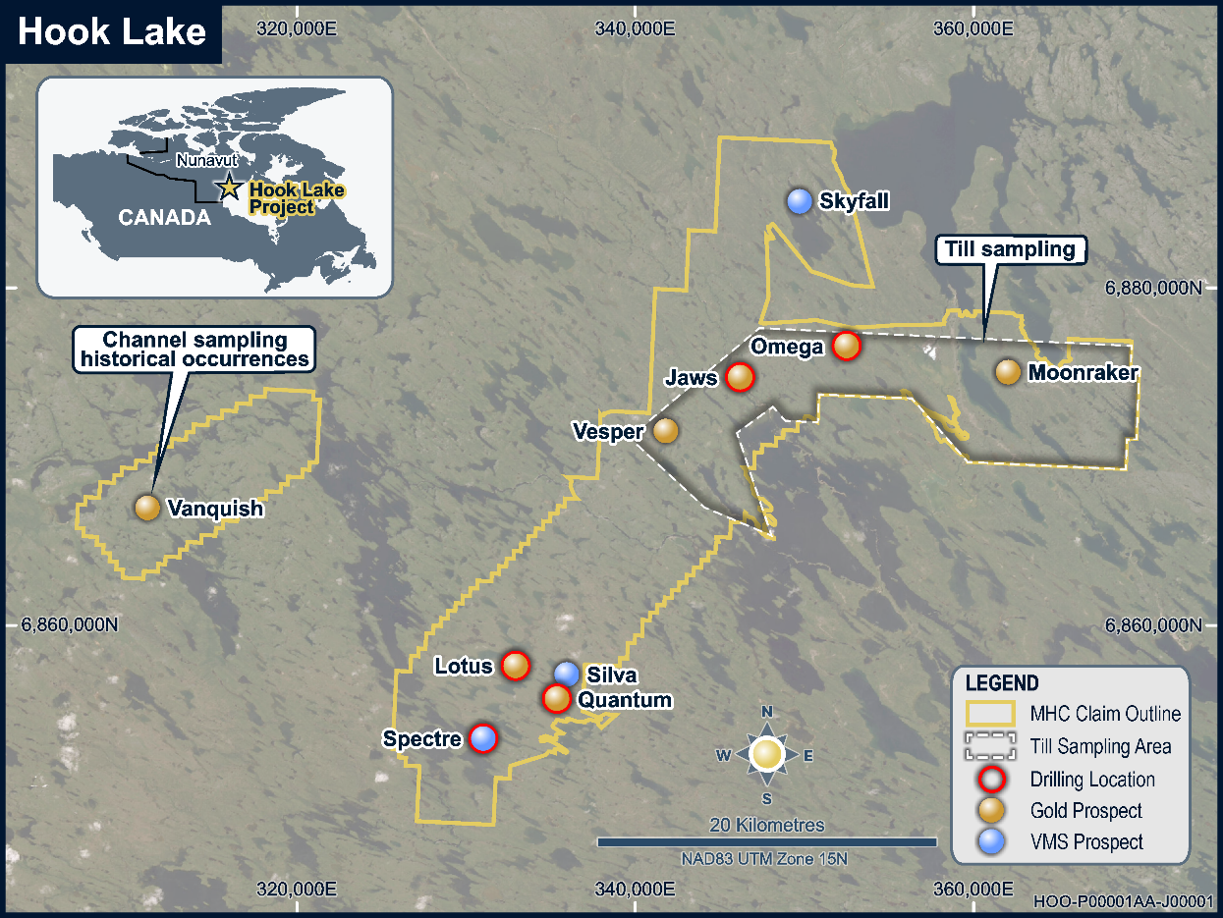
Figure 1: Hook Lake project area with key gold and VMS prospects, including Jaws and Spectre. Figure highlights till sampling area around the Omega and Moonraker prospects interpreted BIF target zone.
Eric Sondergaard, Technical Advisor, Manhattan Gold Corporation Ltd Commented:
“These are exceptional first results for Manhattan. An intercept of 41.15m at 4.66g/t gold, including 7.62m at 18.67g/t, materially elevates the scale and grade potential of the Jaws system.
The result is materially wider and higher grade than the nearest historic intercept and confirms that Jaws hosts very high-grade shoots within a broad mineralised envelope. Historic drilling was sparse and did not define the geometry or full extent of these high-grade zones. We now have a clear opportunity to build scale by tracing this mineralisation along strike and at depth, while targeting additional high-grade shoots across the system.
Jaws is rapidly emerging as the high-grade gold cornerstone of the much larger, district-scale Hook Lake opportunity. Drilling has passed 3,000m, further assays are pending, and we believe we are only beginning to reveal the potential of this system.”

2026 Drilling Program

First assays reveal high-grade gold at Jaws
The most advanced target within the Hook Lake Project is Jaws, where diamond drilling, conducted in the late 1980s, defined a significant “foreign” estimate resource of 3.4Mt @ 2.38g/t Au (~285,000 oz Au), not reported in accordance with the JORC code, 2012.
Manhattan’s initial drilling refined the location of the main shear zone, allowing for holes, including JWS26006b, to target the plunging high-grade shoots noted in historic data. Hole JWS26006b has confirmed their presence and highlighted the discovery potential that exists within the footprint of historic drilling. Drilling in the 1980s often had one drillhole on a section, representing just one data point through what is emerging as a very well-endowed greenstone gold target. Drillhole JWS26006b has:
- Confirmed wider zone of mineralisation than historic drilling, returning 41.15m @ 4.66g/t Au from 83.82m in main shear zone;
- Confirmed exceptional high-grade zones, including:
  - 7.62m @ 18.67g/t Au from 85.34m;
    - 1.52m @ 41.0g/t Au from 86.87m;
    - 1.52m @ 33.40g/t Au from 89.92m;
- Reported higher grades within a thicker mineralised zone than the nearest historic drillhole:
  - Historic hole 133-88-20 returned 22m @ 2.41g/t Au from 100m;
- Confirmed an additional, deeper gold zone commencing with the hole ending in 1.53m @ 0.31g/t Au from 199.64m.

Drillhole JWS26006b results and geological interpretation
JWS26006b was drilled 220m to the SW of drillhole JWS26002 (see figure 2). It targeted the main shear zone at a point where only one historic hole is present, which was drilled towards the NW, effectively down-dip. Despite being drilled towards the SE JWS26006b returned a wider mineralised intercept, and exceptional, higher grade gold values (see figure 3 & 4). The current interpretation is that this drillhole intersected a high-grade shoot, the presence of which are inferred from historic data. Further drilling is required to fully understand the geometry of these important high-grade zones.
Gold mineralisation at Jaws occurs within a broad envelope of pervasive silicification in mafic volcanic rocks, with prolific quartz veining and associated arsenopyrite and pyrite. Alteration can be intense, locally obscuring the protolith and producing iron-carbonate, silicification and talc-rich assemblages.

Drillholes JWS26001 - JWS26003 results and geological interpretation
JWS26001 was drilled to the northwest alongside historic drilling to validate the location and tenor of known mineralisation. Downhole surveying showed that the hole shallowed more than planned, limiting the effectiveness of the deeper test. Nevertheless, JWS26001 returned 79.25m @ 0.78g/t Au from 38.10m, including 33.53m @ 1.04g/t Au from 47.24m and 9.14m @ 2.54g/t Au from 48.77m. The result confirms a broad mineralised system containing higher-grade internal zones and leaves the deeper target open. JWS26008 (see figure 5), which has been completed and is awaiting assays, will effectively test the depth below both JWS26001.
JWS26002 was drilled to the southeast as an effective scissor hole, providing a more favourable intersection of the northwest-dipping mineralised system and testing for stacked quartz vein systems that may have been poorly tested by the 1988 northwest-oriented drilling. The hole returned 9.15m @ 1.99g/t Au from 153.92m, confirming down-dip continuation of the historic footwall vein.
JWS26003 returned 9.15m @ 1.73g/t Au from 35.05m. The hole ended at 103.63m due to ground conditions before reaching the planned deeper target; JWS26003b (assays pending) was subsequently completed at a steeper inclination and reached target depth.
A mix of alternating hard silicified basalt with abundant quartz veining and significantly softer talc intervals, representing intense hydrothermal alteration that can be associated with greenstone-hosted gold settings, caused deviations in the drillholes (see figure 5). Drilling parameters have since changed and further drilling has successfully been completed without deviation, including JWS26008 (assays pending), which will test the depth of the known mineralised zone (see figures 5 & 6).

Comment of historic drilling data
One of the most important outcomes from the first holes is the improved spatial control on the historic Jaws system. The 1988 drill locations were reconstructed from georeferenced scans of paper maps. Modern drilling now indicates the main shear zone is approximately 20-30m northwest of the position inferred from those historic records.
This revised geometry provides a materially stronger basis for follow-up drill targeting. Historic drilling indicates a structurally controlled system containing higher-grade plunging shoots, typical of orogenic and greenstone gold systems. The current interpretation indicates the first holes passed close to, rather than directly through, the targeted higher-grade cores. The information gained from these holes is therefore being used to position follow-up drilling to test the interpreted cores and shoots more directly, together with stacked vein systems and extensions along strike and at depth.

Drilling momentum and assay pipeline
Assays are pending for a further 13 RC drillholes, which now includes two holes at the Spectre volcanogenic massive sulphide target (VMS).
Historic drilling (1974) at the Spectre VMS target returned:
- 10.51m @ 2.91% Cu, 6.70% Zn, 95.67g/t Ag, 1.04g/t Au from 41.76m (GMX-01)
- 13.71m @ 1.51% Cu, 2.06% Zn, 47.23g/t Ag, 0.56g/t Au from 70.26m (GMX-02)
The 1974 drilling program at Spectre was composed of 6 drillholes for a total of 592.53m of shallow drill testing (average of 98.75m end of hole depth).
Separately, RC drilling across the broader 2026 Hook Lake program has now surpassed 3,000m. The expanding drill dataset, together with the completed airborne magnetic survey, acquired LiDAR and planned till sampling, is materially advancing the Company's geological model and target pipeline across the 665km² Project.

Further exploration activities
A regional till sampling program is commencing shortly at the project. This will provide a geochemical dataset spanning from Vesper in the west of the planned survey to Omega and Moonraker in the east. Assay results from the till sampling program will highlight areas of anomalous gold, guided by the now understood pathfinder element assemblage of As-Sb-W. Any gold or pathfinder anomalies in the survey will then be integrated with structural targets inferred from the interpretation of from the recently completed magnetic survey.
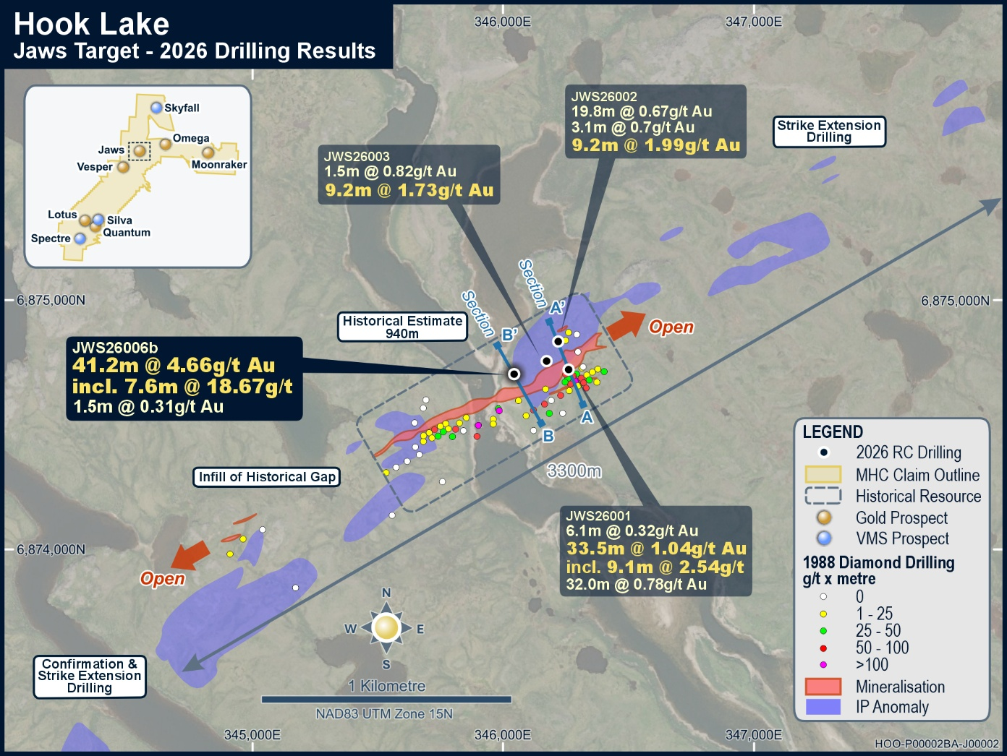
Figure 2: Map depicting the first four drillholes, which targeted the core of the historic drilling. Refer Table 1 for all reported intercepts.
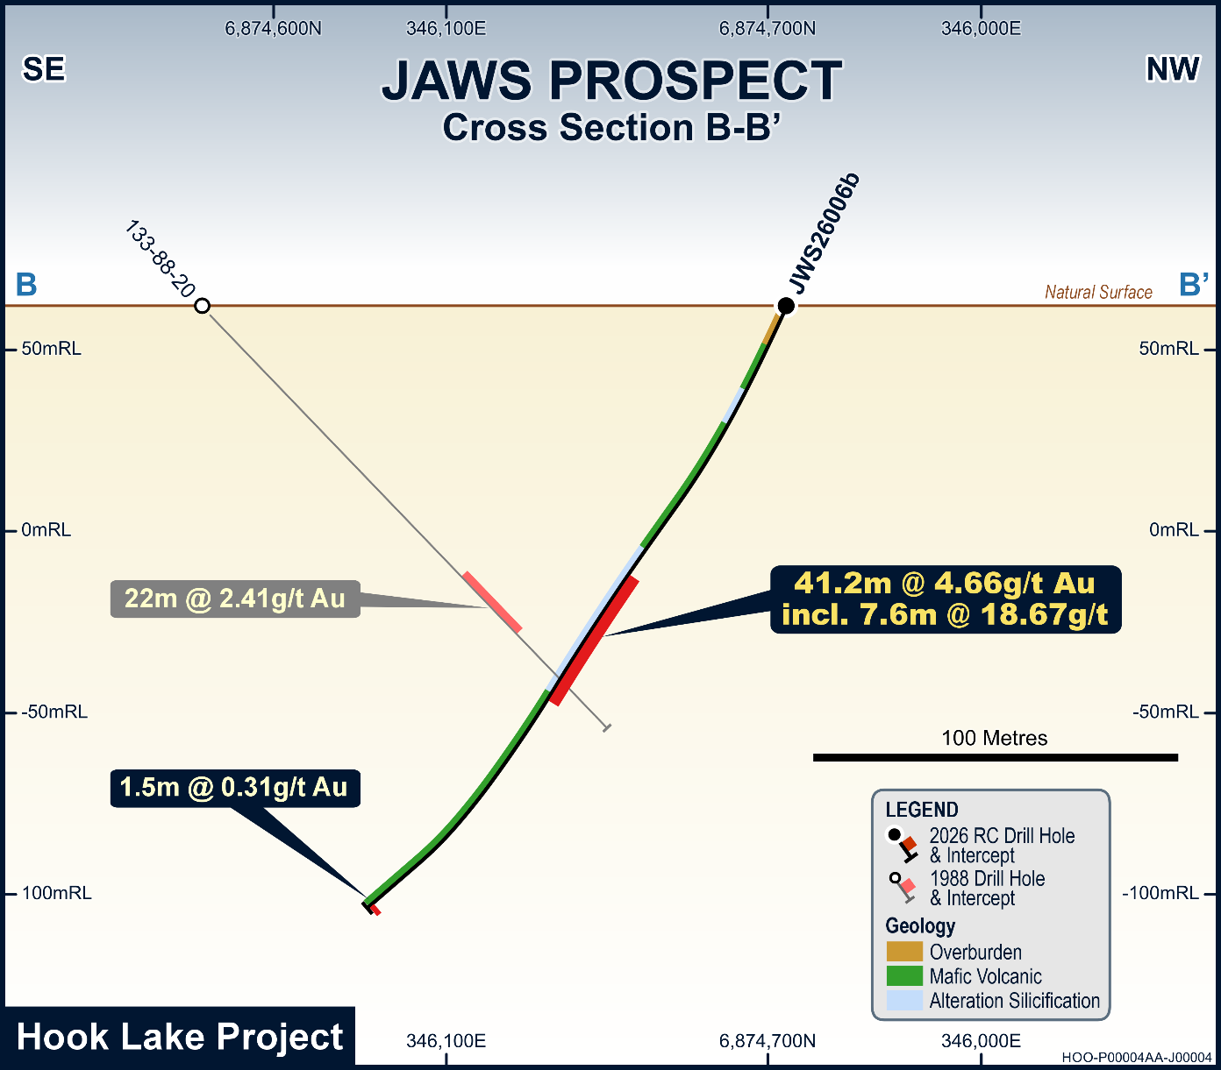
Figure 3: Drillhole section showing the location of JWS26006b compared with historic drillhole from the 1988 program.

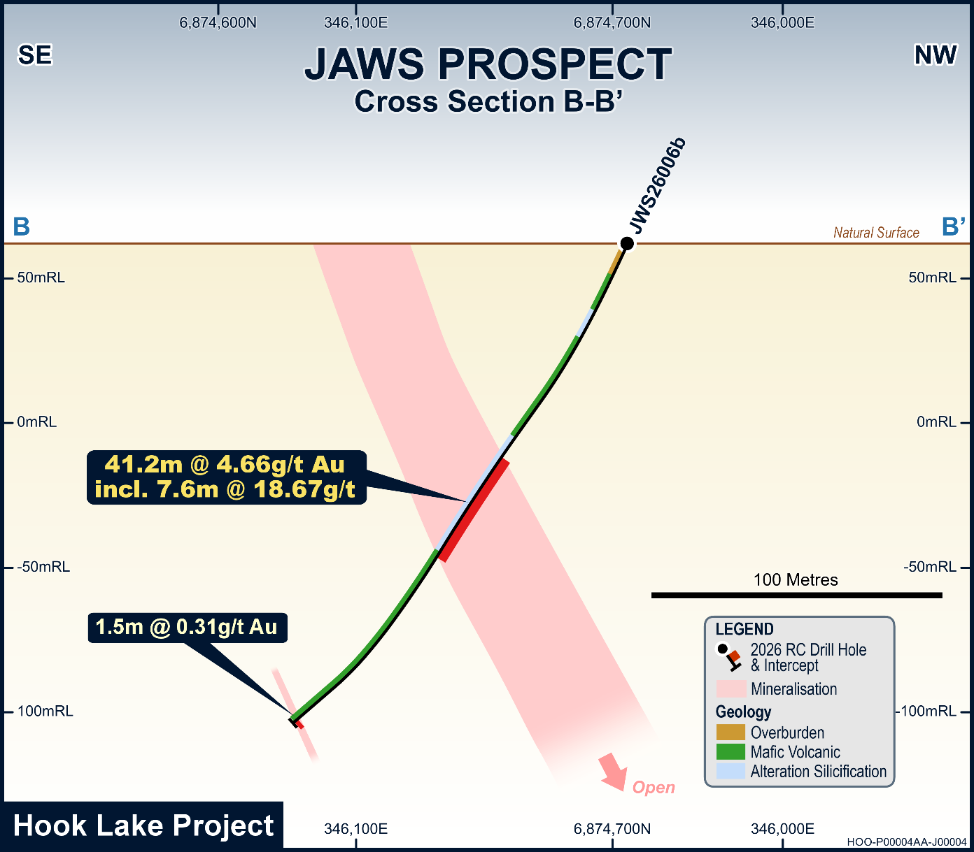
Figure 4: Drillhole section showing the location of JWS26006b without historic drillhole from the 1988 program.
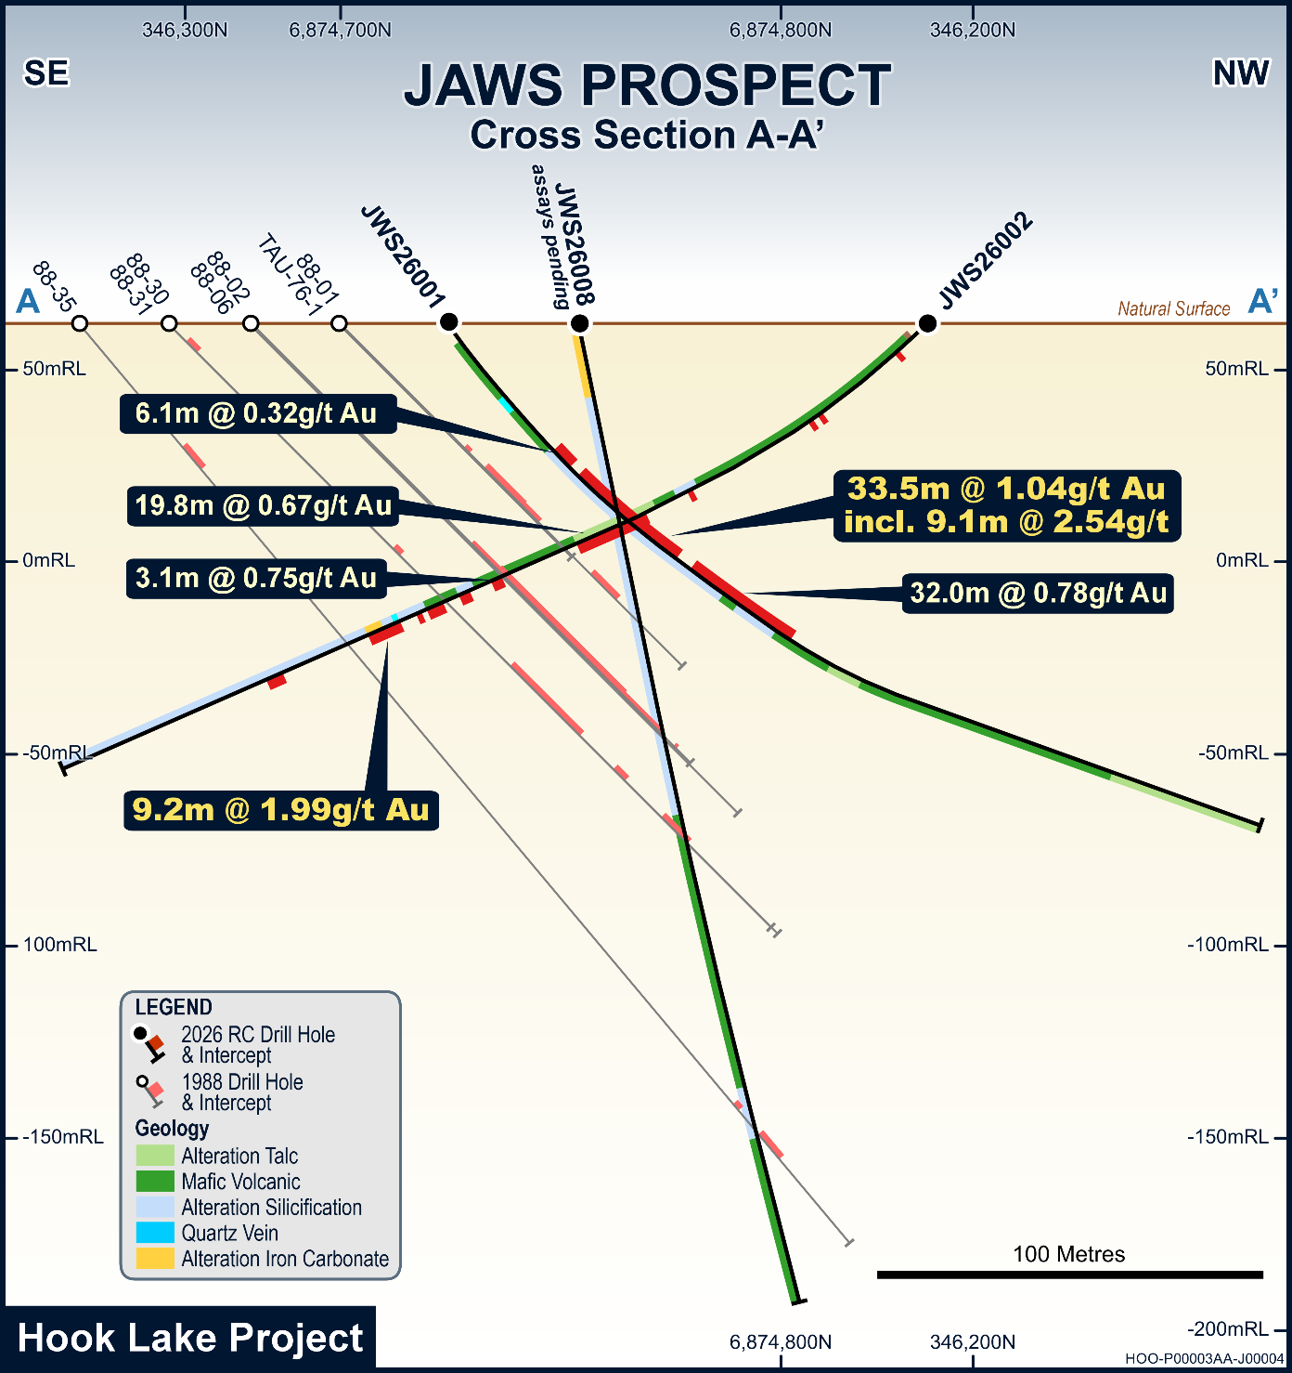
Figure 5: Drillhole section showing the locations of JWS26001 and JWS26002 compared with historic drillholes from the 1988 program. Note the offset of historic drillhole intervals to the SE relative to the main intervals reported by 2026 drillholes. JWS26008 was drilled to confirm the depth extent of historically reported gold intervals.

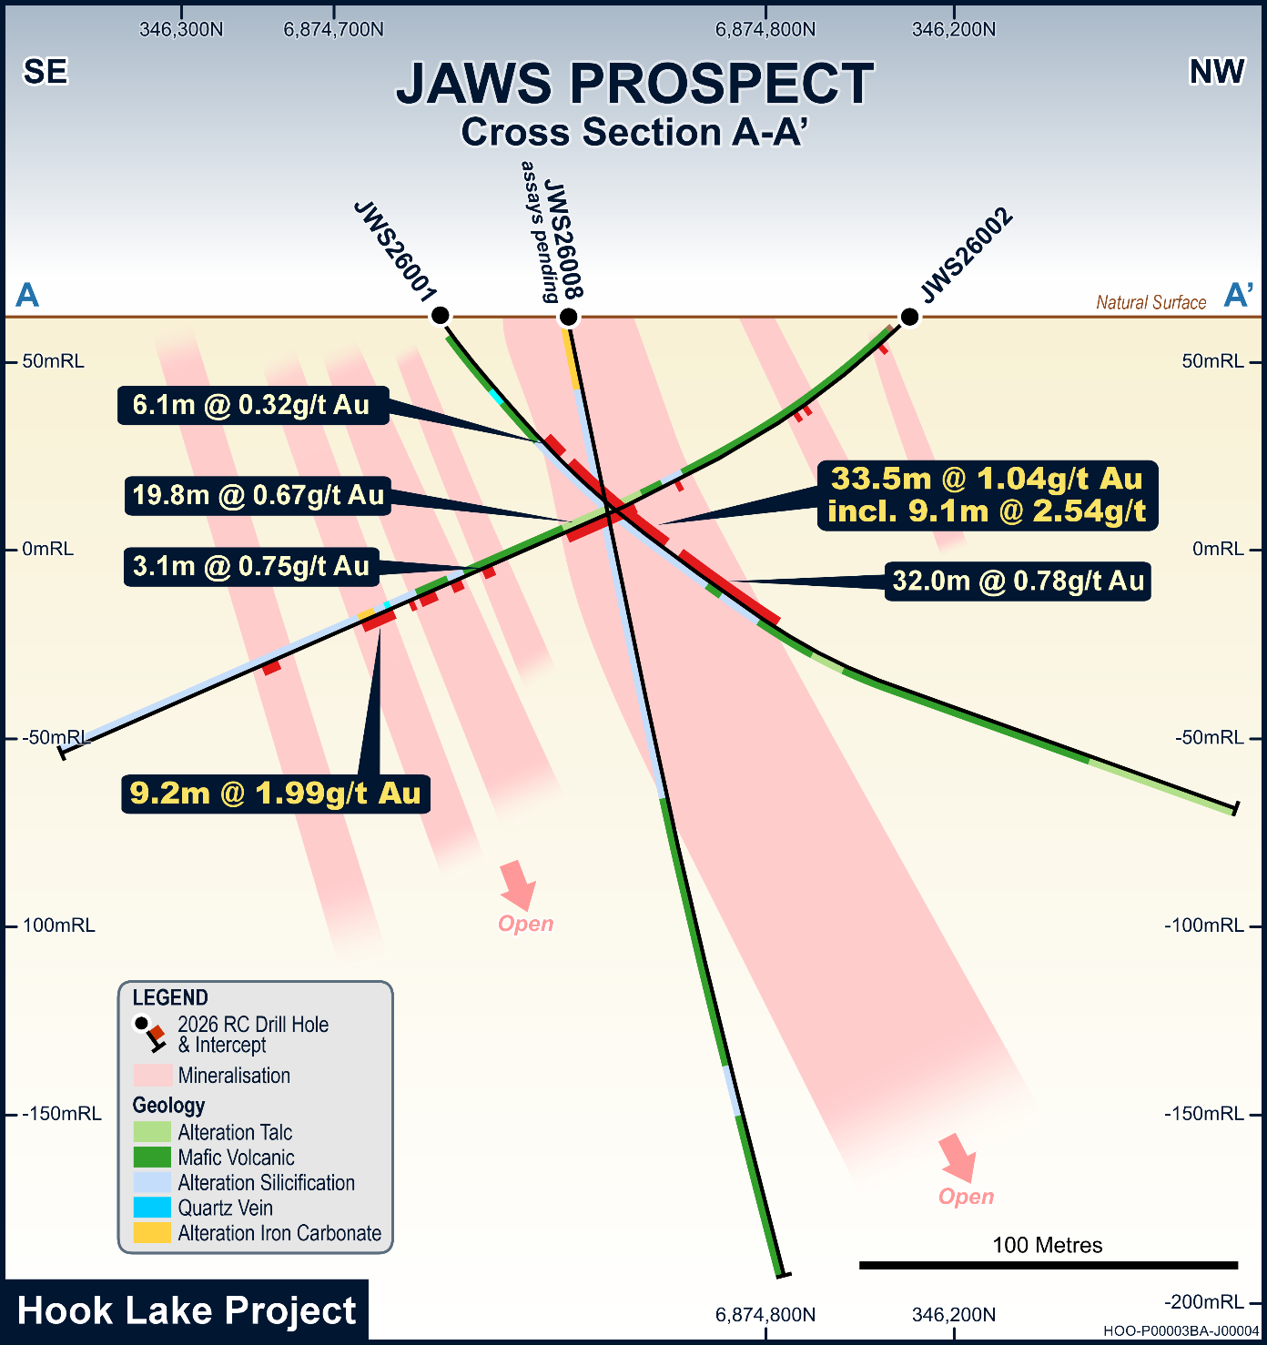
Figure 6: Drillhole section of JWS26001 and JWS26002 without historic drillhole traces. Figure demonstrates the key location of JWS26008 which tested the core of historically reported mineralisation.

Table 1: Significant intercepts from reverse circulation drilling at the Hook Lake Project. Significant intercepts are calculated as an interval >0.1g/t Au with no more than 4.56m of internal dilution (15ft - 3 RC drill rods). Intervals are calculated as simple length weighted averages, minimum sample length is 1.52m governed by the 5ft drill rods, therefore minimum interval length for reporting is 1.52m. Higher grade intervals are labelled as “including” where they form sub-intervals. Reported intervals are drilled lengths not true thicknesses.
Hole ID | From (m) | To (m) | Interval (m) | Au (g/t)
JWS26001 | 38.10 | 117.35 | 79.25 | 0.78
Including | 38.10 | 44.20 | 6.10 | 0.32
Including | 47.24 | 80.77 | 33.53 | 1.04
Including | 48.77 | 57.91 | 9.14 | 2.54
including | 85.34 | 117.35 | 32.01 | 0.78
JWS26002 | 4.57 | 6.10 | 1.53 | 0.11
JWS26002 | 30.48 | 32.00 | 1.52 | 0.57
JWS26002 | 33.53 | 35.05 | 1.52 | 0.12
JWS26002 | 70.10 | 71.63 | 1.53 | 0.22
JWS26002 | 83.82 | 103.63 | 19.81 | 0.67
JWS26002 | 124.97 | 128.02 | 3.05 | 0.18
JWS26002 | 134.11 | 137.16 | 3.05 | 0.75
JWS26002 | 143.26 | 144.78 | 1.52 | 0.93
JWS26002 | 147.83 | 149.35 | 1.52 | 0.80
JWS26002 | 153.92 | 163.07 | 9.15 | 1.99
JWS26002 | 188.98 | 190.50 | 1.52 | 0.14
JWS26003 | 3.05 | 4.57 | 1.52 | 0.82
JWS26003 | 35.05 | 44.20 | 9.15 | 1.73
JWS26003 | 80.77 | 82.30 | 1.53 | 0.28
JWS26006b | 83.82 | 124.97 | 41.15 | 4.66
Including | 85.34 | 92.96 | 7.62 | 18.67
JWS26006b | 199.64 | 201.17 | 1.53 | 0.31
Table 2: Collar location information for the reported drillholes. Collar location taken by Juniper Systems GNS2M geode. (NAD83 UTM Zone 15N)
Hole ID | Easting | Northing | Elevation | Azi | Dip | Depth (m)
JWS26001 | 346255 | 6874722 | 59 | 330 | -55 | 249.94
JWS26002 | 346214 | 6874834 | 58 | 150 | -45 | 249.94
JWS26003 | 346168 | 6874756 | 58 | 150 | -50 | 103.63
JWS26006b | 346038 | 6874704 | 60 | 145 | -65 | 201.17
JWS26008 | 346238 | 6874749 | 60 | 330 | -80 | 259.10

About Hook Lake
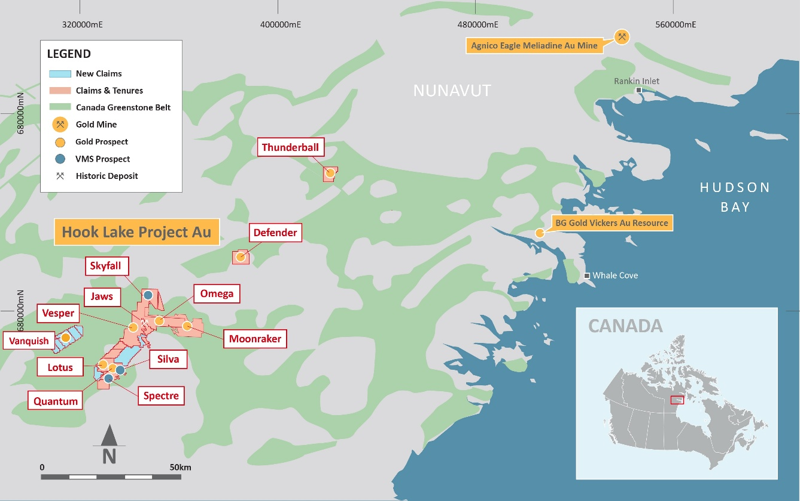
Figure 7: Hook Lake Project area with key gold and VMS prospects
The Hook Lake Project comprises 12 separate prospects covering 665km² within the underexplored Rankin-Ennadai greenstone belt, which also hosts Agnico Eagle's Meliadine mine and BG Gold's Vickers deposit.
Jaws is the most advanced target within the Project, where diamond drilling was conducted in the late-1980s. Beyond Jaws, Hook Lake hosts 11 additional prospective targets, including Quantum and Lotus, which have never been drill tested but returned 16.75g/t and 8.01g/t Au respectively from surface sampling in 2025, and Spectre, a high-grade polymetallic VMS system where historic drilling returned 10.51m @ 2.91% Cu, 6.70% Zn, 95.67g/t Ag and 1.04g/t Au. The Company continues to actively review historic data within the region as evidenced by its staking of Vanquish, an orogenic gold target that returned up to 20g/t Au at surface from rock chip and channel sampling.
Lithologies comprise mafic, intermediate and felsic volcanic rocks together with metasedimentary units including banded iron formations. Three Archean batholiths bound these sequences, while the Turquetil Lake, Spi Lake and Jaw Lake regional shear zones transect the Project on a broadly northeast trend.

Authorised for Release
This announcement has been authorised for release by the Board.

For further information contact Bayard Rezos, General Manager
Phone: +61 8 9322 6677 or Email: brezos@mhc.gold
Level 17, Exchange Tower
2 The Esplanade, Perth WA 6000
ABN: 61 123 156 089

About Manhattan Gold Corporation Ltd
Manhattan Gold Corporation Ltd (ASX: MHC) is an early-stage gold and polymetallic exploration company focused on emerging exploration projects in tier 1 jurisdictions. Current exploration projects include Hook Lake in Nunavut, Canada (665km²) within the Rankin-Ennadai greenstone belt, the second largest greenstone belt in Canada, and Tibooburra in New South Wales, Australia (2,195km²) within the emerging Koonenberry Gold District. The Company is committed to responsible exploration in partnership with Inuit and First Nations communities.
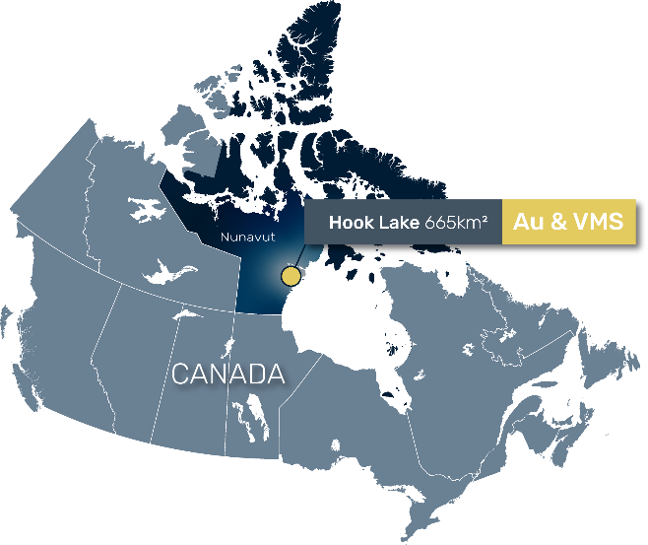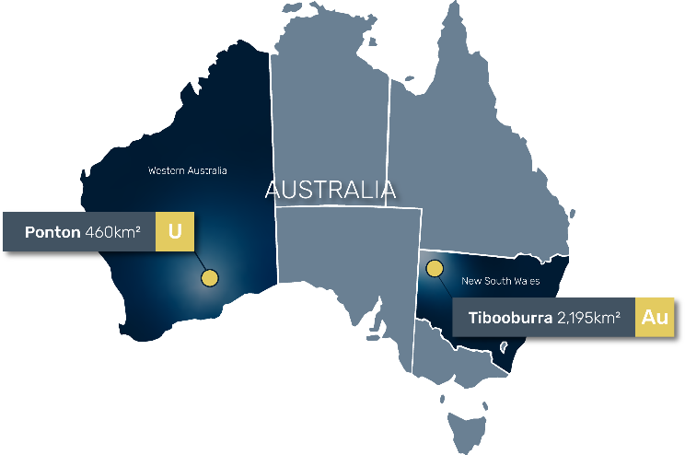
Supporting ASX Announcements: The following announcements were lodged with the ASX and further details (including supporting JORC Tables) for each of the sections noted in this Announcement can be found in the following releases. The Company confirms that it is not aware of any new information or data that materially affects the information included in the original market announcements. Note that these announcements are not the only announcements released to the ASX but are specific to exploration reporting by the Company of previous work at the Hook Lake Project.
- 21st July 2026 – “High-Grade Gold Momentum Accelerates at Hook Lake with New Vanquish Prospect Delivering up to 20.0 g/t Au”
- 7th July 2026 – “Manhattan Completes LiDAR Survey and Channel Sampling at Hook Lake”
- 23rd June 2026 – “Manhattan Commencing Drilling at Hook Lake”
- 28th May 2026 – “Manhattan Receives Formal Drilling Approval and Cash Grant”
- 7th May 2026 – “Manhattan Expands Mineral Exploration Agreement with Nunavut Tunngavik Incorporated”
- 1st April 2026 – “New Gold Prospects Secured West of the Hook Lake Project”
- 23rd March 2026 – “Drill Contract Awarded for Hook Lake”
- 18th March 2026 – “Hook Lake Project Cleared for Drilling”
- 18th March 2026 – “Strongly Supported A$3M Placement to Advance Hook Lake High Grade Gold and Polymetallic Project in Nunavut, Canada”
- 13th November 2025 – “Up to 173.5g/t Gold from Wider Regional Targets At Hook Lake Project”
- 3rd November 2025 – “Outstanding Widespread Polymetallic Grades from Hook Lake Project”
- 27th October 2025 – “Up to 16.75g/t Gold and 2,660g/t Silver Sampled at Untested Targets of the Hook Lake Project”
- 23rd October 2025 – “Assays Confirm up to 14.5g/ton Gold at Jaws and Significant Expansion Potential Along Strike”
- 16th October 2025 – “Corporate and Hook Lake Project Update”
- 25th September 2025 – “High Grade Gold Hook Lake Project Expanded”
- 3rd September 2025 – “Completion of Maiden Fieldwork Programme - Additional Information”
- 6th August 2025 – “Completion of Placement to advance Hook Lake Project”
- 29th July 2025 – “$2.2m Placement to advance Hook Lake Project”
- 24th July 2025 – “Completion of High Grade Gold & Copper Acquisition”
- 21st July 2025 – “Field Activities to Commence at Hook Lake”
- 27th May 2025 – “High Grade Gold & Copper Acquisition – Amended”
- 12th May 2025 – “High Grade Gold and Copper Acquisition”

Competent Person Statement: The information in this report that relates to historical estimates and exploration results is an accurate representation of the available data and studies for the Project, is based on, and fairly represents, information either compiled or reviewed by Mr Kell Nielsen who is a Fellow of the Australasian Institute of Mining and Metallurgy. Mr Nielsen is a Non-Executive Director of Manhattan Gold Corporation Limited. Mr Nielsen has sufficient experience which is relevant to the style of mineralisation and type of deposit under consideration and to the activity which he is undertaking to qualify as a Competent Person (CP) as defined in the 2012 Edition of the Joint Ore Reserves Committee (JORC) “Australasian Code for Reporting of Exploration Results, Mineral Resources and Ore Reserves”. Mr Nielsen consents to the inclusion in the announcement of the matters based on his information in the form and context in which it appears.
Forward-Looking Statements: This announcement may contain certain ‘forward looking statements’ which may not have been based solely on historical facts but rather may be based on the Company’s current expectations about future events and results. Forward-looking statements contained in this announcement include but are not limited to completion of the Proposed Transaction; the strengths, characteristics and potential of the Company following completion; timing and receipt of shareholder approvals; discussion of future plans, projects and objectives.

Appendix A: JORC Code 2012 – Table 1

The following Tables are provided for the reporting of Exploration Results at the Project LR 5.12 reliability factors.

Section 1: Sampling Techniques and Data
(Criteria listed in the preceding section also apply to this section)
Criteria | JORC Code explanation | Commentary
Sampling techniques | - Nature and quality of sampling (e.g., cut channels, random chips, or specific specialised industry standard measurement tools appropriate to the minerals under investigation, such as downhole gamma sondes, handheld XRF instruments, etc.). These examples should not be taken as limiting the broad meaning of sampling.  - Include reference to measures taken to ensure sample representivity and the appropriate calibration of any measurement tools or systems used.  - Aspects of the determination of mineralisation that are Material to the Public Report.  - In cases where ‘industry standard’ work has been done this would be relatively simple (e.g., ‘reverse circulation drilling was used to obtain 1 m samples from which 3 kg was pulverised to produce a 30 g charge for fire assay’). In other cases, more explanation may be required, such as where there is coarse gold that has inherent sampling problems. Unusual commodities or mineralisation types (e.g., submarine nodules) may warrant disclosure of detailed information. | 2026 Reverse Circulation Drilling – Manhattan Gold Corporation  - Reverse circulation (RC) drilling was used to obtain 1.52m samples (5ft). Sample material was passed through a 2-tier riffle splitter to produce an assay sample and a retention sample. The assay samples were transported back to the remote field camp before being shipped to ALS Yellowknife using CalmAir Cargo. Certificates for chain of custody are maintained.  - Samples analysed by ALS Laboratories. Samples prepared under code PREP31 which entails crushing until 70% passing <2mm, followed by riffle splitting a 1kg sub sample for pulverising to 75um. Pulps then analysed by ICP-AES after 4 acid digestion for 33 elements, and gold determined by Au-ICP22, a 50g charge fire assay and ICP-AES analysis. Samples over 1% Cu, As, Zn, Pb or 100g/t Ag are re-assayed by OG62 methods. Over 10g/t Au samples re-assayed by gravimetric finish Au-GRA22 with 50g charge.  - Portable XRF data are gathered for each sample, however, are not reported in this release. They are only used as aids for logging geologists. Magnetic susceptibility measurements are taken on each sample using a KT-10 instrument.
Drilling techniques | - Drill type (e.g., core, reverse circulation, open-hole hammer, rotary air blast, auger, Bangka, sonic etc.) and details (e.g., core diameter, triple or standard tube, depth of diamond tails, face-sampling bit or other type, whether core is orientated and if so, by what method, etc.). | 2026 Reverse Circulation Drilling – Manhattan Gold Corporation  - Northspan Explorations Ltd. The drillholes were sampled in their entirety on 5-foot (1.52m) intervals. Returned material was passed through a levelled 2-tier riffle splitter, producing a sample split for assay and a retention sample. Representative chips for logging were taken from the retention sample by sieving. Chips are washed at the rig location, prior to storage in chip trays and transport back to the remote field camp for logging. Another small bag of chips is collected from the retention sample and used for pXRF measurements.  - Drilling was completed by reverse circulation (RC) drilling methods by Northspan Explorations Ltd. utilising a heli-portable hornet machine. 5-foot rod intervals with a 3.5-inch face sampling hammer with inner-tube assembly and 3.5-inch string diameter.
Drill sample recovery | - Method of recording and assessing core and chip sample recoveries and results assessed.  - Measures taken to maximise sample recovery and ensure representative nature of the samples.  - Whether a relationship exists between sample recovery and grade and whether sample bias may have occurred due to preferential loss/gain of fine/coarse material. | 2026 Reverse Circulation Drilling – Manhattan Gold Corporation  - An estimation (qualitative) of recovery is completed on the sample returned from the complete drill interval by the RC sampler.  - If loss is noticed a discussion between sampler and driller is undertaken and notes recorded alongside the sample.  - Sample bias is believed to be negligible due to a preferential loss of fine/coarse material.  - Riffle splitting of the returned material generates a homogenous sample for the 5ft interval, ensuring representative sampling.  - Field duplicate samples are taken by spearing the homogenised retention sample, post riffle splitting to produce a sample of similar mass to the original (parent) sample.
Logging | - Whether core and chip samples have been geologically and geotechnically logged to a level of detail to support appropriate Mineral Resource estimation, mining studies and metallurgical studies.  - Whether logging is qualitative or quantitative in nature. Core (or costean, channel, etc) photography.  - The total length and percentage of the relevant intersections logged. | 2026 Reverse Circulation Drilling – Manhattan Gold Corporation  - All returned intervals from RC drilling are logged by a geologist at the remote field camp. A Nikon microscope is used to assist this process.  - All chip trays are photographed for records.  - Photographs of intervals of interest are taken and stored within the MX Deposit logging software.  - Logging is completed to a high standard however are not yet influencing a mineral resource estimation, mining study or metallurgical testwork.
Sub-sampling techniques and sample preparation | - If core, whether cut or sawn and whether quarter, half or all core taken.  - If non-core, whether riffled, tube sampled, rotary split, etc and whether sampled wet or dry.  - For all sample types, the nature, quality and appropriateness of the sample preparation technique.  - Quality control procedures adopted for all sub-sampling stages to maximise representivity of samples.  - Measures taken to ensure that the sampling is representative of the in situ material collected, including for instance results for field duplicate/second-half sampling.  - Whether sample sizes are appropriate to the grain size of the material being sampled. | 2026 Reverse Circulation Drilling – Manhattan Gold Corporation  - RC drillholes are sampled in their entirety  - Samples derived from a 2-tier riffle splitter that produces an assay sample and a larger retention sample  - Samples are generally dry, if wet a note is made by the RC sampler  - Sample size is deemed appropriate for the style of mineralisation, a 2-tier riffle splitter is used rather than a 3-tier to generate a larger sample for assay  - If nuggety gold is encountered larger assay samples can be taken for future programs, to date no coarse-grained gold is known that would require special attention when sampling drilling material  - Field duplicates are used to monitor sampling representivity
Quality of assay data and laboratory tests | - The nature, quality and appropriateness of the assaying and laboratory procedures used and whether the technique is considered partial or total.  - For geophysical tools, spectrometers, handheld XRF instruments, etc., the parameters used in determining the analysis including instrument make and model, reading times, calibrations factors applied and their derivation, etc.  - Nature of quality control procedures adopted (e.g., standards, blanks, duplicates, external laboratory checks) and whether acceptable levels of accuracy (i.e., lack of bias) and precision have been established. | 2026 Reverse Circulation Drilling – Manhattan Gold Corporation  - Samples analysed by ALS Laboratories. Samples prepared under code PREP31 which entails crushing until 70% passing <2mm, followed by riffle splitting a 1kg sub sample for pulverising to 75um. Pulps then analysed by ICP-AES after 4 acid digestion for 33 elements, and gold determined by Au-ICP22, a 50g charge fire assay and ICP-AES analysis. Samples over 1% Cu, As, Zn, Pb or 100g/t Ag are re-assayed by OG62 methods. Over 10g/t Au samples re-assayed by gravimetric finish Au-GRA22 with 50g charge.  - Quality control samples are inserted into the sample stream at a rate of 10% consisting of coarse blanks CDN BL-10T or OREAS C26e, certified reference material OREAS 236b and CDN-GS-1P5X, and field duplicates. These are assessed by MHC technical staff  - pXRF data is collected but not reported, it’s primary purpose is for assisting logging geologist
Verification of sampling and assaying | - The verification of significant intersections by either independent or alternative company personnel.  - The use of twinned holes.  - Documentation of primary data, data entry procedures, data verification, data storage (physical and electronic) protocols.  - Discuss any adjustment to assay data. | 2026 Reverse Circulation Drilling – Manhattan Gold Corporation  - All significant intercepts are reviewed by the company Sr. Geologist/Technical Advisor and Non-Executive Director alongside the Competent Person.  - No twinned holes are reported. The location of historic 1980s drilling is only approximately located through georeferencing of historic PDF maps into modern GIS software. 2026 drilling by MHC has determined the georeferencing of historic collars to be up to 30m offset.  - Data is entered into the company MX Deposit workspace where it is stored.  - There is no adjustment to assay data.
Location of data points | - Accuracy and quality of surveys used to locate drillholes (collar and down-hole surveys), trenches, mine workings and other locations used in Mineral Resource estimation.  - Specification of the grid system used.  - Quality and adequacy of topographic control. | 2026 Reverse Circulation Drilling – Manhattan Gold Corporation  - Planned holes are predetermined and coordinates are stored in MX Deposit, actual coordinates are then surveyed using a Juniper systems GNS2M geode and stored alongside the planned coordinates.  - Downhole surveys are completed at the end of hole consisting of a continuous gyro survey and single shot surveys  - Coordinates are reported in NAD83 datum, either UTM Zone 15N or UTM Zone 14N.  - Topographic control is achieved using a 2m resolution ArcticDEM.
Data spacing and distribution | - Data spacing for reporting of Exploration Results.  - Whether the data spacing, and distribution is sufficient to establish the degree of geological and grade continuity appropriate for the Mineral Resource and Ore Reserve estimation procedure(s) and classifications applied.  - Whether sample compositing has been applied. | 2026 Reverse Circulation Drilling – Manhattan Gold Corporation  - Drill collars are planned between 30 and greater than 100m apart for exploration purposes, wider spaced holes, or isolated holes will be used to test exploration prospects  - No sample compositing in reported data  - Data spacing is not yet sufficient to inform geological or grade continuity
Orientation of data in relation to geological structure | - Whether the orientation of sampling achieves unbiased sampling of possible structures and the extent to which this is known, considering the deposit type.  - If the relationship between the drilling orientation and the orientation of key mineralised structures is considered to have introduced a sampling bias, this should be assessed and reported if material. | 2026 Reverse Circulation Drilling – Manhattan Gold Corporation  - JWS26001 was purposefully drilled within the historic drillholes, which is in part down dip of the mineralisation which is known to trend NE/SW and dip steeply to the NW – this was to validate historic drilling data and not to inform on true thickness, the reported interval is not true thickness. JWS26001 was drilled approximately perpendicular to the strike of mineralisation however was drilled down-dip and therefore has an element of sample bias.  - Further drillholes are planned drilling perpendicular to the strike of the mineralisation towards the SE which is opposite the known dip of the steeply dipping to the NW vein systems. This will not introduce sampling bias and will report nearer true thickness intervals.
Sample security | - The measures taken to ensure sample security. | - Samples are stored in a remote field camp; they are then shipped to Yellowknife from Arviat using CalmAir freight services. In Yellowknife samples are received by Aurora Geosciences and delivered to ALS Laboratories preparation laboratory Yellowknife. Chain of custody forms are completed and kept for records. Security zip locks are used to ensure bags have not been opened in transit.
Audits or reviews | - The results of any audits or reviews of sampling techniques and data. | An independent audit of the historic data was completed in March 2025 by Michael Martin of OMNI GeoX for Pinwheel Resources. The key positives of the project directly from the review were:  - Access to a landholding within the Nunavut greenstone terrains, which hosts multiple +1Moz deposits:  - Significant landholding covering historical prospect areas, including Turquetil Lake, Seahorse Lake, Hook Lake, and Spi Lake.  - Approximately 30 km of strike length along the prospective Turquetil Lake shear zone and parts of the Jaw Lake and Spi Lake shear zones. The width of the Turquetil Lake shear zone is unknown. However, it is believed to be at least 400 metres wide.  - The tenure hosts the Turquetil Lake gold deposit, which has a non-JORC compliant resource of 3.4 Mt at 2.38g/t Au, amounting to 260 Koz, and is open down dip and along strike.  - The deposit is polydeformed and structurally controlled by faults and shear zones  - The Project area has the rock types that host the significant gold deposits in the region, and there are reports of the presence of banded iron formations in the region, which is a major gold orebody host rock in the Nunavut greenstone terrain. High-quality airborne magnetics will identify these units.  - The orebody contains high-grade zones that would be amenable to underground mining.  - Possible ore zones exist in the footwall and hanging wall of the current mineralisation.  - Geochemical anomalies are present along strike of the Turquetil Gold deposit to the northeast and southwest.  - The region hasn’t undergone any recent or modern exploration since the 1990s; therefore, modern, more sensitive geophysical techniques could uncover new targets.  - There are multiple prospects at various stages of progression; this will allow for the setting of a process of systematic exploration of the project.  - The project can provide a positive news flow to the market  - Rock types hosting mineralisation include many types including mafic, ultramafic, sedimentary, and volcanoclastic; however, the most favourable host is Banded iron formations  - Ore deposits consist of multiple lodes in the shear zone system up to 1km wide.  The key risks identified, directly from the review, were:  - Resource Models – the is no information regarding how the resources were calculated, apart from the mention of the tonnes and grade in the Geological field report  - Drilling orientation - The drilling orientation has been drilled partly down dip. Therefore, the intercept widths are exaggerated. Unsure whether this may be an issue in the resource models.

Section 2: Reporting of Exploration Results

(Criteria listed in the preceding section also apply to this section)
Criteria | JORC Code explanation | Commentary
Mineral tenement and land tenure status | - Type, reference name/number, location and ownership including agreements or material issues with third parties such as joint ventures, partnerships, overriding royalties, native title interests, historical sites, wilderness or national park and environmental settings.  - The security of the tenure held at the time of reporting along with any known impediments to obtaining a licence to operate in the area. | - The Project is made up of 26 mineral claims in 5 blocks and 3 Mineral Exploration Agreements.  - The Mineral Exploration Agreements are between Mr Eric Sondergaard, Director of 6106 Resources Limited a wholly owned subsidiary of Manhattan Gold Corporation, and Nunavut Tunngavik Incorporated (NTI) for IOL parcels AR16 and AR25. Under the agreement a 100% mineral interest is granted for a period of 20 years.  - All mineral claims are in good standing.  - MHC possesses an Inuit Land Use License from the Kivalliq Inuit Association, which is valid 2 years (upon which it can be renewed annually without additional screening), and allows the licensee to complete staking and prospecting, exploration, bulk fuel storage, RC drilling and temporary camp establishment.  - MHC also possesses a Crown-Indigenous Relations and Northern Affairs Canada (CIRNAC) land use permit, which is valid for 5 years and can be extended for a further 2 years. The permit allows the licensee to complete staking and prospecting, exploration, bulk fuel storage, drilling and camp establishment.  - MHC’s current Nunavut Water Board (NWB) permit allows water for camp and ancillary purposes (<49m³).  - There is a 2% net smelter royalty included as part of the Hook Lake Project acquisition.
Exploration done by other parties | - Acknowledgment and appraisal of exploration by other parties. | - First reported exploration in the area was conducted by Giant Yellowknife Mines in the early 1960s on a gold showing near the east bank of the Turquetil River, just north of its mouth into the Turquetil Lake. Regional mapping of the project, conducted by the Geological Survey of Canada in the early 1970s classified this and other gold showings in a lithological setting that is considered akin to the Larder Lake carbonate-hosted gold deposits.  - In 1976 Essex Minerals Co. conducted a minor drilling program and discovered significant intervals of gold mineralisation beneath the surface showing. No infill or tight drill spacing was completed.  - In 1987 Dejour and Noble Peak staked 18 claims comprising around 15,000 hectares to explore for a Larder Lake-type carbonate-hosted gold deposit. The property was expanded in 1988 to 40,000 hectares. Regional and detailed mapping, prospecting and detailed channel sampling were carried out by Dejour in 1987 and continued in 1988 with the assistance of airborne electromagnetic and magnetic surveys. In 1988 a total of 10,500 m of diamond drilling in 64 holes was completed.  - Work completed in 1988 defined a corridor of iron-carbonate alteration hosted within mafic and intermediate flows and tuffs, stretching 13 km to the southwest from the Turquetil Lake gold occurrence. Drilling efforts defined over 940m of strike length of continuous gold mineralisation, with a further three holes to the southwest (False Lake) extending this possible footprint to 1.64 km along trend.  - A local prospector, John Tugak completed a short field visit in 2017 conducting limited rock chip sampling of quartz veins and alteration zones. The project was briefly held by MPH consulting in 2020/21 however no meaningful work was completed.
Geology | - Deposit type, geological setting and style of mineralisation. | - The Project is host to known orogenic gold mineralisation hosted within shear zones and volcanogenic massive sulphide mineralisation hosted in the Archean volcanic rocks.  - Regionally located in the Western Churchill province of Northwestern Canada, a poly-deformed Archean greenstone belt primarily comprising metamorphosed volcanic and sedimentary rock.  - Gold is associated with pyrite and arsenopyrite in a zone of quartz-veined, carbonatized mafic volcanics coincident with the Turquetil Lake Shear Zone (TLSZ). It is inferred that gold mineralisation occurred after intense carbonatization, which acted as ground preparation for the later gold bearing hydrothermal fluids. Veining, alteration and sulphide presence increases with proximity to the shear zones.  - The Turquetil Lake area hosts the Turquetil Lake Gold deposit. The Turquetil property is situated within the Rankin-Ennadai greenstone belt, which features rocks from the Kaminak and Hurwitz formations. These formations consist of mafic, intermediate, and felsic volcanic rocks, along with metasedimentary units that include oxide iron formation. Three Archean batholiths bound these formations. The structure of the Turquetil region comprises three steeply-dipping regional shear zones: the Turquetil Lake Shear Zone (TLSZ), the Spi Lake Shear Zone (SLSZ), and the Jaw Lake Shear Zone (JLSZ), which trend northeast and align roughly with the stratigraphy in the central and southern region.
Drillhole Information | - A summary of all information material to the understanding of the exploration results including a tabulation of the following information for all Material drillholes:  - easting and northing of the drillhole collar  - elevation or RL (Reduced Level – elevation above sea level in metres) of the drillhole collar  - dip and azimuth of the hole, down hole length and interception depth, hole length.  - If the exclusion of this information is justified on the basis that the information is not Material and this exclusion does not detract from the understanding of the report, the Competent Person should clearly explain why this is the case. | 2026 Reverse Circulation Drilling – Manhattan Gold Corporation  - The collar details of all reported drillholes are tabulated in the release.
Data aggregation methods | - In reporting Exploration Results, weighting averaging techniques, maximum and/or minimum grade truncations (e.g., cutting of high grades) and cut-off grades are usually Material and should be stated.  - Where aggregate intercepts incorporate short lengths of high-grade results and longer lengths of low-grade results, the procedure used for such aggregation should be stated and some typical examples of such aggregations should be shown in detail.  - The assumptions used for any reporting of metal equivalent values should be clearly stated. | 2026 Reverse Circulation Drilling – Manhattan Gold Corporation  - Weighted averages are reported. This is calculated as a simple weighted average of the gold grade in g/t against the length of the sample. These are combined to give an average.  - A significant intercept has been defined as an intercept of >0.1g/t Au with no more than 4.56m of internal dilution (15ft as per 3 x 5ft RC drill rods)  - No high grades have been capped.  - No metal equivalents are used or reported.
Relationship between mineralisation widths and intercept lengths | - These relationships are particularly important in the reporting of Exploration Results.  - If the geometry of the mineralisation with respect to the drillhole angle is known, its nature should be reported.  - If it is not known and only the down hole lengths are reported, there should be a clear statement to this effect (e.g., ‘down hole length, true width not known’). | 2026 Reverse Circulation Drilling – Manhattan Gold Corporation  - JWS26001 was purposefully drilled within the historic drillholes, which is in part down dip of the mineralisation which is known to trend NE/SW and dip steeply to the NW – this was to validate historic drilling data and not to inform on true thickness, the reported interval is not true thickness. JWS26001 was drilled approximately perpendicular to the strike of mineralisation however was drilled down-dip and therefore has an element of sample bias.  - Further drillholes are planned drilling perpendicular to the strike of the mineralisation towards the SE which is opposite the known dip of the steeply dipping to the NW vein systems. This will not introduce sampling bias and will report nearer true thickness intervals.  - True thickness is not currently known. Drillhole results are reported as drilled lengths not true thicknesses.
Diagrams | - Appropriate maps and sections (with scales) and tabulations of intercepts should be included for any significant discovery being reported These should include, but not be limited to a plan view of drillhole collar locations and appropriate sectional views. | - Location maps provided within the release with relevant exploration information contained.
Balanced reporting | - Where comprehensive reporting of all Exploration Results is not practicable, representative reporting of both low and high grades and/or widths should be practiced avoiding misleading reporting of Exploration Results. | - All known or compiled exploration results have been reported where considered to be material by the competent person at the time of release.  - Further compilation of the historic data may lead to further information that may be material.  - MHC plans to complete compiling of historic data and further data and or information will be added during this process that is not know or has not been compiled at the time of this release  - The reporting of exploration results is considered balanced by the competent person.
Other substantive exploration data | - Other exploration data, if meaningful, should be reported including geological observations; geophysical survey results; geochemical survey results; bulk samples – size and method of treatment; metallurgical test results; bulk density, groundwater, geotechnical and rock characteristics; potential deleterious or contaminating substances. | 2025/2026 Airborne Magnetic Survey (MHC)  - An airborne magnetic survey is underway at the Hook Lake Project. It is being flown by Terraquest Ltd based out of Rankin Inlet Airport.  - Aeromagnetic horizontal gradiometer data is being collected.  - The survey will cover the main block of exploration agreements and mineral claims in the SW of the Hook Lake Project.  - Data is being collected on 165/345 degrees trending lines spaced 100m apart, with a smaller zone of 50m infill lines covering key targets Vesper-Jaws-Omega. Tie lines are flown 1km apart oriented 075/255 degrees.  - 60m drape mode terrain clearance.  2026 LiDAR – Manhattan Gold Corporation  - A fixed wing aircraft (twin engine Piper Navaho), flying at 230 to 250 km/hr at an altitude of 1900m above ground flew 46 lines over the Hook Lake Project.  - Average 1050m between flight lines  - Data collected generated by infared laser at 10 pulses per m squared (aggregate first return density) using equipment capable of returning multiple points per pulse.  1992 Placer Dome Magnetics  - After completion of 1988 and 1989 Dighem survey this data was integrated with GSC historic magnetic surveys.  - GSC surveys were flown at 152 or 305m terrain clearance, to match the Dighems terrain clearance of 45m the GSC data underwent a downward continuation  - Merged datasets were gridded and filtered to produce a first vertical derivative  Other  - Historic geophysical data – The project area is host to historic geophysical data, however this exists in paper format and has not been georeferenced due to local grid systems and a lack of topographic features on the maps to aid referencing. Work is ongoing to integrate these datasets.  - Surface geochemical data – The project area is covered by a regional till sampling campaign “Till sampling survey, Turquetil Lake area, Nunavut, 1988” which contains multielement and gold assay results for till samples taken around the project area. <0.063 mm fraction by ICP-AES after nitric-aqua regia (3HCl:1HNO3) digestion for 21 elements; by dry fusion fire assay for Au; by ICP-atomic fluorescence after HNO3 digestion for platinum group elements. <0.002 mm fraction by AAS after hot HNO3-HCl digestion for 14 elements. Non-ferromagnetic heavy mineral fraction (0.125-0.250 mm pulverized to 0.063 mm) for suite of elements (NRCAN Open File 2132).  - Density measurements – In 1988 Dejour Mines Limited and Noble Peak Resources conducted specific gravity measurements on 134 core intervals which had returned gold intervals in 9 drillholes. An average of 2.95 g/cm³ was determined with a range of 2.71-3.32 g/cm³.  - Metallurgy – (Source publication NUMIN 083123) In 1989 metallurgical test work completed by Lakefield Research demonstrated a 94.6% recovery rate for gold using a 3-step process of:  - Preparation of a floatation concentrate,  - Pressure oxidation,  - Cyanidation.  - Microscopy – NUMIN publication 083123 notes the results of previous microscopy work completed by Robinson & Thompson 1989 and Miller 1989 on the Turquetil Lake gold mineralisation. It states gold is in association with pyrite and arsenopyrite, also with native gold found as discrete grains in four mineralogical associations:  - As inclusions in pyrite and/or arsenopyrite,  - In contact with grains of chalcopyrite which are inclusions in pyrite or arsenopyrite,  - Along the contact between arsenopyrite grains and altered gangue,  - As discrete grains in altered host rock that also carries arsenopyrite.  - Electron microprobe analysis of gold grains in the late pyrite show gold-silver ratios of 49:1, similar to other deposits in the region (Miller, 1989).
  Equipment:
  Cesium Vapour Magnetometer(s) | 3 X Scintrex CS-3 or CS-L
  3-axis Fluxgate Magnetometer | Billingsley TFM100-LN
  VLF-EM | Terraquest Ltd: Matrix Digital VLF-EM
  Navigation GPS Receiver | Novatel ProPak-V3 L1L2 with real time WAAS or equivalent correction
  Navigation system | AgNav Inc. P151 Linav system
  GPS Receivers (3) | Hemisphere R320
  Radar Altimeter | King KRA 10A
  Barometric Altimeter | Honeywell (PPT0020AWN2VA-C)
  Acquisition and Magnetic Compensation | RMS Instruments DAARC 500
  Stinger specifications:
  Longitudinal Sensor separation | 9.2 metres
  Lateral Sensor separation | 14.6 metres
  FOM Tail Sensor (requirement) | <1.5 nT
Further work | - The nature and scale of planned further work (e.g., tests for lateral extensions or depth extensions or large-scale step-out drilling).  - Diagrams clearly highlighting the areas of possible extensions, including the main geological interpretations and future drilling areas, provided this information is not commercially sensitive. | - An airborne magnetic survey has been completed; this will be filtered to produce maps of magnetic intensity. These maps will be used to interpret lithological and structural geology applied to ore deposits and form an important part of future target generation and drillhole planning.  - Maiden RC drilling is underway at the property, this will focus on confirming and outlining extensions to the known gold mineralisation at Jaws and Spectre.  - A regional scale till sampling survey is planned to be completed as part of the 2026 field season. This will assist in targeting extensions to the known Jaws gold deposit and generating targets within the banded iron formation to the east which is largely under glacial cover.  - Integration of all data will be completed during Q4 2026 and will inform the planning of 2027 field activities.

See announcements “High Grade Gold and Copper Acquisition” 12 May 2025 and “High Grade Gold & Copper Acquisition – Amended” 27 May 2025
The Company notes that the Resource estimate quoted above for Jaws, is a “Foreign” estimate and is not reported in accordance with the JORC Code or previous iterations of acceptable reporting codes. Relevant information in relation to the work program, methodology, summary of key material assumptions and parameters utilized to calculate the estimate is not available to the Company at this time and the Company has relied on extracts from published reports in quoting the estimate. A competent person has not done sufficient work to classify the “Foreign” estimate as Exploration Results or Mineral Resources or Ore Reserves in accordance with the JORC Code. There are no more recent estimates available. It is uncertain that, following further evaluation and/or further work that the historical estimates will be able to be reported in accordance with the JORC Code (2012). Refer to ASX announcement 27/05/2025 – “High Grade Gold & Copper Acquisition – Amended” for further details
Refer to MHC Announcements 12/05/2025 “High Grade Gold and Copper Acquisition” and 27/05/2025 “High Grade Gold & Copper Acquisition – Amended”
Refer to MHC Announcement 12/05/2025 “High Grade Gold and Copper Acquisition” and 27/05/2025 “High Grade Gold & Copper Acquisition – Amended”
Refer to MHC Announcement 27/10/2025 “Up to 16.75g/t Gold and 2,660g/t Silver Sampled at Untested Targets of the Hook Lake Project”
Refer to MHC ASX Announcement 01/09/2025 “Completion of Maiden Fieldwork Programme”

